DESIGN AND IMPLEMENTATION OF AN ONLINE STUDY GROUP DISCUSSION FORUM FOR COMPUTER SCIENCE STUDENTS

BY:

SAMSON TOPE FISAYO

14/CSH/0617

BEING A SEMINAR PAPER SUMBITTED TO THE

DEPARTMENT OF COMPUTER SCIENCE, FACULTY OF INFORMATION AND COMMUNICATION TECHNOLOGY, OSUN STATE POLYTECHNIC, IREE.

IN PARTIAL FULFILMENT OF THE REQUIREMENTS FOR THE AWARD OF HIGHER NATIONAL DIPLOMA (HND) IN COMPUTER SCIENCE

NOVEMBER 2016

CERTIFICATION

This is to certify that this seminar paper was carried out by SAMSON TOPE FISAYO with MATRIC NO: 14/CSH/0617 in the Department of Computer Science, Faculty of Information and Communication Technology, Osun State Polytechnic,Iree.

---------------------------------------------- ------------------------------------

MR. O.A Oduwole Date

Supervisor

----------------------------------------------- ------------------------------------

MR. S.F Oladoye Date

Head of Department

ABSTRACT

*Study Group Discussion is refer to as a communicative situation that allows its participants to express views and opinions and share with other participants. It is a systematic exchange of information, views and opinions about a topic, issue, problem or situation among members of a group who share certain common objectives. Study group discussions are held by students to share ideas and explain to themselves in clear terms a subject area or course of study. It involves coming together of students physically and electronically to discuss and share ideas and information among themselves. The developed system was developed by creating the following interfaces; the User homepage environment, User registration page, Administrator homepage and Administrator delete user page. The developed system was implemented using Mysql and Php. The performance evaluation of the system was carried out by administering questionnaires on twenty users after which the completed copies were collected and used for result analysis. The result of evaluation of the developed system showed that 19 out of 20 users agreed that the system is fast and accurate. Also 19 out of 20 users agreed that the system is accessible. It is then concluded that in this work an on-line Study group discussion forum that is capable of ensuring speedy and accessible means of accepting users information, allow them to log in, share information and discuss issues about their courses among themselves has been developed.*

*Keywords:* Study Group Discussion, Online Study Group Discussion Forum, Discussion Forum

**INTRODUCTION**

Study Group Discussion is refer to as a communicative situation that allows its participants to express views and opinions and share with other participants. It is a systematic exchange of information, views and opinions about a topic, issue, problem or situation among members of a group who share certain common objectives. Study Group Discussion helps problem solving, decision making and personality assessment. Students need to participate in academic discussions to help them with their courses (Margaret Rouse, 2011). An On-line discussion forum is a virtual place on the internet where conservations can take place and information can be shared more easily among a geographically dispersed group of people. Discussion forums are typically created around a specific topic of common interest or for a specific user group around a particular piece of work (Simon, 2011). This present era has been termed to be an information age, an age where the demand for information has dramatically increase, the internet has been the most useful place for getting information nowadays, the use of search engines is one of the most useful, the internet is not just used for getting information but for also socializing and exchanging ideas and information, this has led to the development of several software and applications, ranging from the development of online communities and interactive applications.

Sylvia (2007) explains that, an online forum is a type of interactive website for holding discussions and posting user generated content, usually each conversation has its own screen, with the original posting at the top, and responses listed in reframe. A sense of virtual community often develops around forums that have regular users. It is an instance of interactive web. Forums differ from chat rooms and instant messaging because forum participants do not have to be online at the same time, they suit short posts, which request a response from others.

Statement of Problem

Investigation has revealed that the traditional approach to group studying among Computer Science students of Osun State Polytechnic Iree is associated with the following problems;

1. Sharing of information, ideas among themselves
2. Discussing issues about their courses and finding solution to it by asking questions and posting answers to it

Hence, an Online Study Group Discussion Forum that is capable of sharing information, ideas and discussing about their courses was designed, implemented and evaluated in this project work.

Aim and Objectives of the Project

The project is aimed at developing an On-line Study Group Discussion Forum for Computer Science Students of Osun State Polytechnic. The specific objectives are:

1. To design an On-line Study Group Discussion Forum for Computer Science students of Osun State Polytechnic.
2. To implement the designed system using PHP and MYSQL.
3. To evaluate the performance of the developed system by computing it with the existing system.

The Research Approach

The method for the research approach is as follows:

1. The design of the developed Research Based Online Study Group Discussion Forum system was carried out.
2. The developed of a Research Based Online Study Group Discussion Forum was implemented using Php and Mysql.
3. The developed system was evaluated by conjoin the existing system with the new system.

LITERATURE REVIEW

On-line Discussion Forum is a form of electronic communication which facilitates interaction based on certain interests and characteristics. Discussion forum are media for social interaction, using highly accessible and scalable publishing techniques. Discussion forum use web-based technologies to transform and broadcast media monologues into social dialogues (Idakwo, 2011). An On-line discussion media network platform is one that provides a medium for interaction by groups of people making it easy to share information (such as lecture materials, pictures and ideas) across a circle of people or groups. Statistics has shown that the use of social network such as Facebook, Twitter and LinkedIn is on the increase most especially among young individuals, the crop of which are students of tertiary institutions (Ikhu-Omoregbe, 2012).

History of Online Discussion Forums

According to Idakwo (2011), Online discussion has been around since computers were first networked. One of the original intentions of the internet was to make it easy for scientists to collaborate. The most important early discussion forums were on USENET, which started in 1979. Discussion forums later became the base for many online communities. The most recognizable use of discussion forum was through innovative application, an online dialogue framework, created by Ward Christensen, a former IBM employee and Randy Suess. Initially, they envisioned a place where they could immediately contact their co-employees for announcements, i.e. meetings, reports, and other affairs, rather than making multiple phone calls, distributing memos, and the like. They were looking into creating a computerized bulletin board, which is why they named the program CBBS (Computerized Bulletin Board System). Soon enough, more and more employees contributed their ideas and comments in the said online community. That event was a momentous episode in the history of computer and internet. It was the birth of online social networking. The CBBS platform was made known to other companies and has been used for specific purposes. The Bulletin Board System expanded largely and began breaking into the mainstream much sooner than it was planned to. It was during the rise of the Internet Service Providers in the early 1990s when social networking sites began to flourish. Along with the availability of internet service to people, many people rummaged to have themselves acquainted with this new technology. With the fast response of people to the budding internet community, the bulletin boards which were usually used by companies have started to expand their roles by offering their service to more people around the globe. More and more people joined the online community with the innate goal of creating an identity in this space and at the same time exploring the vast place that is the internet. Because of this, many internet-savvy companies gave what people wanted- getting to know more people and sharing common interests and points of view; that is through websites where they can socialize, websites which are now referred to as social networking sites. Social media attained a great measure of success with the launch of the then very popular friendster.com. Creator of Friendster, Jonathan Abrams concocted a perfect mix of popular features from earlier social networking predecessors. Friendster became an instant success and gathered about three million members who signed up in its early months of launch. As years passed, Friendster reached an overwhelming hundred million users from all over the globe. With much demand from its users, Friendster unfortunately got out of hand and suffered from too many glitches in the server. Today, Friendster has been announced as a newly owned entity of a Malaysian Company, and outshone by present social networking sites but still remains to be patronized most especially in Asia. The conception of myspace.com opened the internet users to vast opportunities of selfexpression which include wide control over a user’s profile content. Practically different people from all walks of life have dedicated pages in MySpace. In MySpace, users experienced the best of creating unique identities to show to the online world. MySpace remained as the uncontested favorite among all the social networking sites until 2005when it met its future competitor in the market. Soon enough, MySpace created additional features like mobile applications in order to keep up with the latest trends in the online community; and at the same time be at par with the growing popularity of contemporary social networking sites, more specifically the next thing in line. (Chopra,2013). Facebook started as a local social network made for the students of Harvard. It was developed by a sophomore, Mark Zuckerberg. Facebook was actually made by hacking Harvard’s database containing identification images of students. The initial idea was actually to compare the faces of students with images of animals, for entertainment purposes. However, due to the potentially damaging contents of the site, the creators decided to put it down before it caught the attention of school authorities. The application was shut down, but the idea of creating an online community of students came to existence. The platform was then improved and sooner than they expected, Facebook was released in campuses other than Harvard. Thereafter, high schools were already starting to get attracted to the idea of having online communities, thus opening the website to the younger population. In 2006, facebook.com ultimately offered the opportunity to the rest of the world. As 2007 approached, the registrants reached an overwhelming digit-roughly a million dozen (Chopra, 2013). Facebook has grown to become the biggest and most popular social networking site today with a population of above 500 million active users.

What is an Online Forum?

Online forums provides a unique type of social environment that enables people to share and access information freely. Users can either start new topics or leave comments in the threads of existing topics. Usually, an online forum has tens or hundreds of distinct boards or communities. These boards or communities group hundreds to thousands of threads of similar related topics together. Because of the huge numbers of users and the high dynamics of online forums, this type of environment has a rich complexity (Vicente, 2008). An Online forum is also a system designed for the discussion of topics, with each topic separated into its own area, called a thread. A thread is begun by a user writing a short document, called a post, which introduces the topic or asks a question about the topic (Liu, 2010). Internet users search online forums, generally, for two types of information. Some of them search the forums for subjective information such as different viewpoints, opinions, emotions, evaluations, etc., on specific problems instead of a single correct answer (Prakhar, 2012).

Features of an Online Forum

The ability of online forums to be able to submit threads and posts brought the invention of new web technologies/features. In this project, some of these under-listed features will be used like private messages and emoticons. These are some standard features of an online forum:

1. Tripcodes and Capcodes: In a tripcode system, a secret password is added to the user's name following a separator character (often an octothorpe). This password, or tripcode, is hashed into a special key, or trip, distinguishable from the name by HTML styles. Tripcodes cannot be faked but on some types of forum software they are insecure and can be guessed (cave76, 2009).

2. Private Messages: There are three reasons for this; you are not registered and/or not logged

on, the board administrator has disabled private messaging for the entire board, or the board administrator has prevented you from sending messages. Contact a board administrator for more information (Cave76, 2009).

3. Attachment: An attachment is a file or image uploaded to go with a post. It can be a convenient way for members to share documents and photos. The administrator sets who can attach files, how many per post, how large, and what types and size they can be in the Attachments and Avatars center (SMF Online Manual, 2013).

4. BBCode and HTML: It is not possible to post HTML on this board and have it rendered as HTML. Most formatting which can be carried out using HTML can be applied using BBCode instead (Cave76, 2009).

5. Emoticon: Emoticons are essentially textual representations of oral discourse markers, generally utilized to convey a writer’s sense of emotion and involvement. It is also a mode of representing a writer’s feelings in communication. (Halvorsen, 2012)

6. Poll: As with posts, polls can only be edited by the original poster, a moderator or an administrator. To edit a poll, click to edit the first post in the topic; this always has the poll associated with it. If no one has cast a vote, users can delete the poll or edit any poll option. However, if members have already placed votes, only moderators or administrators can edit or delete it. This prevents the poll’s options from being changed mid-way through a poll (Cave76, 2009).

7. RSS and ATOM feeds: The RSS (Rich Site Summary and Really Simple Syndication) feed is not human readable. It is an XML format which is designed to be read by machines rather than humans. There are different versions of RSS in use. RSS 2.0 is the most common. It is used for news/blog feeds as well as for Podcasting. A newer format, called Atom, is a more standardized way of providing XML content updates. However, it has not gotten wide acceptance yet outside of the blog communities (Cave76, 2009).

8. Other Features include avatars, ignore lists, subscriptions and cookies.

The Existing Group Discussion Forum System

The current Study group discussion forum in Computer Science of Osun State Polytechnic, Iree is Whatsapp which allows students to discuss issues about their courses and also pass out information among themselves. It is obvious that the system is only meant for the HND2 students and the owner of the system can decide to shut it down at anytime he/she likes. Other problems with the system include the use of only android phones, so students with java phones or blackberry cannot participate in the group discussion.

The Newly Developed Online Study Group Discussion Forum

The newly developed system is designed to allow the Computer Science Students of Osun State Polytechnic, Iree to share information, ideas and discuss issues about their courses. The benefits of this web application include: easy access to information, streamlined interaction between students, fostering social interactions, no loss of relevant information, security & access form anywhere. It is flexible and requires nothing more than a computer system with access to the web. Online Study Group discussion forum provides users with the following features:

Register: This is where the new user will register his/her username and password that will be used to be login into the Discussion forum.

Login: This is where the new user will input his/her username and password

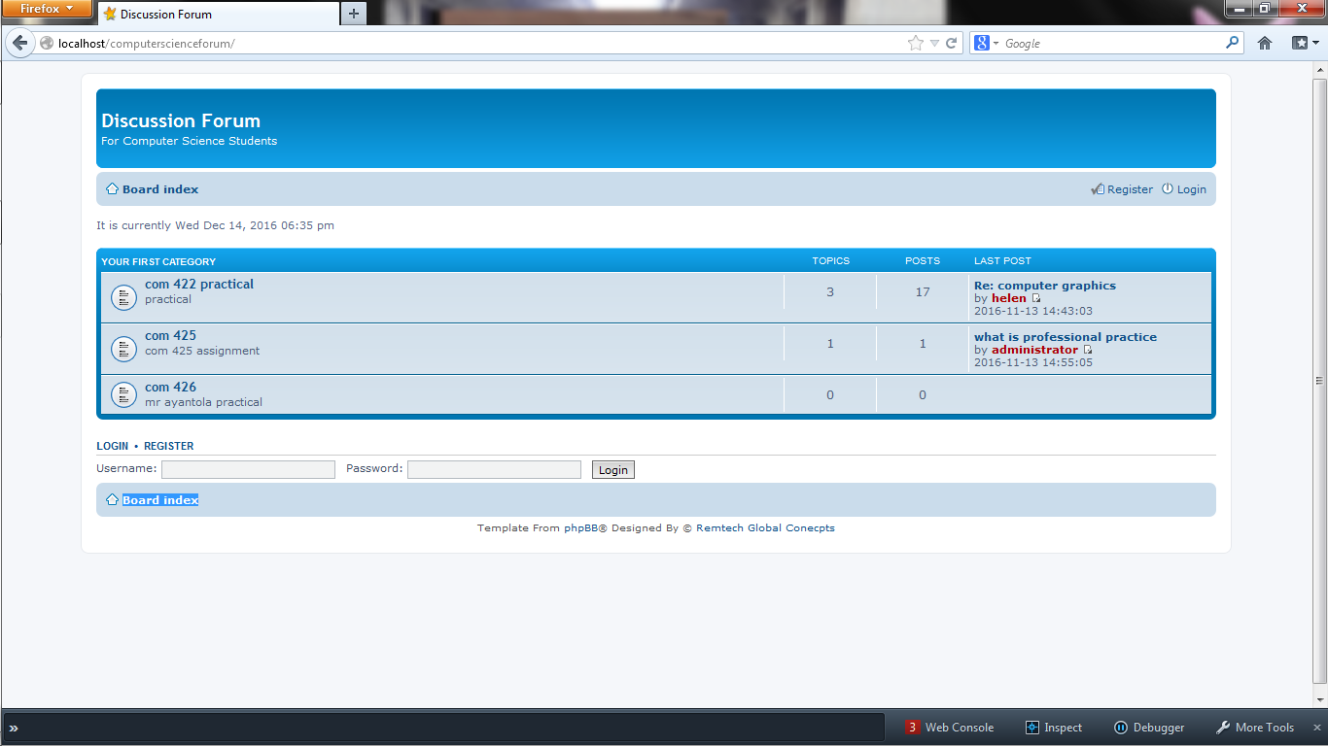

Figure 1

Result and Discussion

Result

The result of the evaluation of the developed system is as presented in the table below

Table 1.The table of responses from users on usabilty of the system.

|  |  |  |
| --- | --- | --- |
| The designed system is easy to use | Frequency (users) | Percentage |
| Strongly Agree | 17 | 85% |
| Agreed | 2 | 10% |
| Disagreed | 1 | 5% |
| Strongly Disagree | 0 | 0% |
| Total | 20 | 100 |

Figure 2 Graphical Representation of the responses of the users on usability

Table 2. The table of responses from the users on accessibility of the system

|  |  |  |
| --- | --- | --- |
| The designed system is easy to access | Frequency (users) | Percentage |
| Strongly Agree | 17 | 85% |
| Agreed | 2 | 10% |
| Disagreed | 1 | 5% |
| Strongly Disagree | 0 | 0% |
| Total | 20 | 100 |

Figure 3. Graphical Representation of the responses of the users on accessibility

Discussion

Table 1 and figure 2 shows that 19 users out of 20 users agreed and only 1 disagreed that the developed system is easily accessible. Also table 2 and figure 3 shows that 19 out of 20 users agreed that the system is very fast in operation from the result shown in the table. It is concluded that majority of the users agreed that the system is easy to access and fast in operation.

CONCLUSION AND FUTURE WORK

As the Online Study Group Discussion forum grows, online study group discussion forums like ComputerScienceForum will be relevant to Computer science students in the computer science department. Even as other versions will be later developed, the activities and features on the site will increase because they will be built to meet the end-users requirements. It is concluded from the result of the implementation that the developed system is usable, easily accessible and it provide a secured database system for Study Group online Discussion Forum for Computer Science Students has been developed. The system can be improved and the following recommendations are made for future work:

1. The developed system should be used for Computer Science Students of Osun State Polytechnic, Iree in order to share information and discuss issues among themselves.
2. The developed should be extended to provide access to all the students in the Polytechnic environment.

REFERENCES

Cave76, (2009, February 8). Learning about Internet forums. Retrieved March 5, 2014, from

http://www.lymeneteurope.org/forum/viewtopic.php?f=8&t=2446

Chopra, K., (2013, May 23). Social media today. Retrieved March 5, 2014 from

[http://socialmediatoday.com/karenn1617/1745751/effects-social-media-how-wespeak- and-write](http://socialmediatoday.com/karenn1617/1745751/effects-social-media-how-wespeak-%20%20and-write) Falls, J, (2012). Why Forums May Be the Most Powerful Social Media Channel for Brands.

Halvorsen, A., (2012). Patterns of Emoticon Usage in ESL Students’ Discussion Forum Writing.

Computer-Assisted Language Instruction Consortium, 29(4), pp. 694-717.

Idakwo, L., (2011). *The Use of Social Media among Nigerian Youths.* [Online]

Available at: http://www.<slideshare.net/goldlami/the-use-of-social-media-among-nigerianyou>ths2[Accessed 20 January 2014].

Ikhu-Omoregbe, N., Ayo, C., Azeta, A. & Macus, V., (2012). Towards Developing an Online

Social Media-based Mobile Learning System. *African Journal of Computing & ICT,* December,5(6), pp. 45-46.

Margaret, R, (2011). Study Group Discussion. New York: facts on File, Inc.

Prakhar, B., Sumit, B., Cornelia, C. & Prasenjit, M., (2012). Thread Specific Features Are

Helpful For Identifying Subjectivity Orientation of Online Forum Threads. COLING.

Simon, B., Steve, M. & Ray, F., (2006). Object-Oriented Systems Analysis and Design Using

UML. 3rd ed. s.l.:McGraw-Hill Higher Education.

SMF Online Manual, (2013). Attachment. [Online]

Available at: <http://wiki.simplemachines.org/smf/Attachment> [Accessed 5 March 2014].

Vicenç, G., Andreas, K. & Vicente, L, (2008). Statistical Analysis of the Social Network and

Discussion Threads in Slashdot. Beijing, WWW.